**Forward Finite Difference**

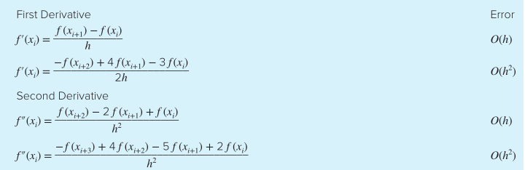

**Backward Finite Difference**

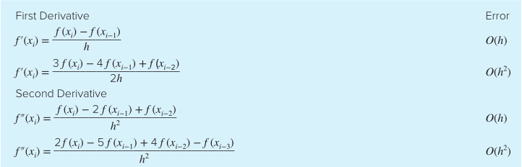

**Centered Finite Difference**

